From Refugee to Retiree
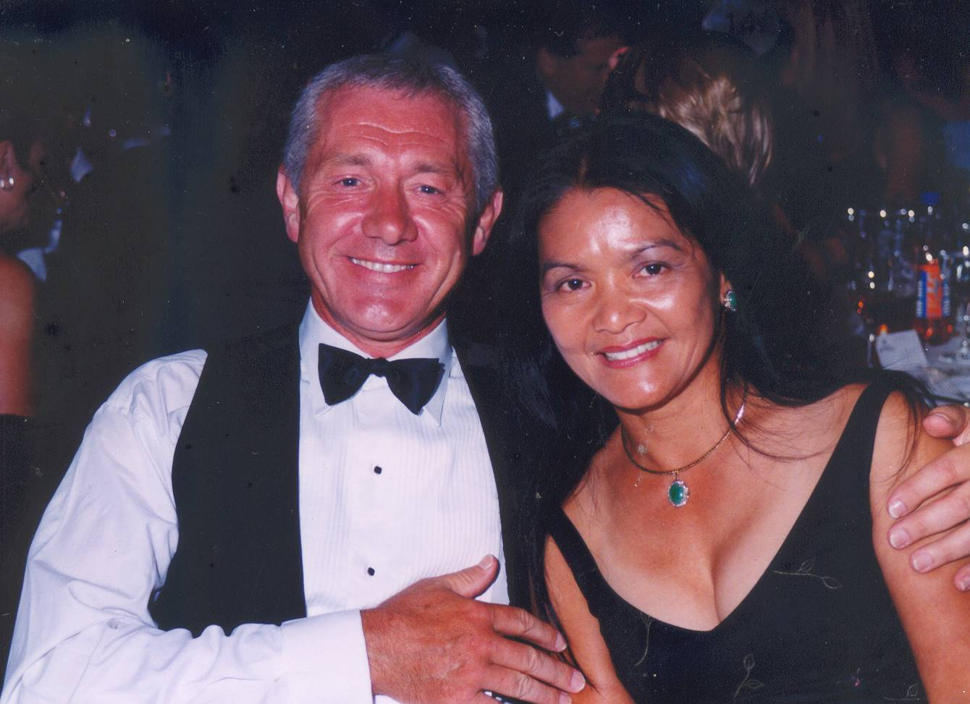
Hue Thomson, a 47-year-old woman, living in Sydney with her husband, David Thomson, has faced many challenges in her life. The average woman’s challenge is getting to work on time or controlling the household. What’s the bet they never had to travel from Vietnam to Hong Kong on a tiny fishing boat just as Hue Thomson did?
Sammy Manson

Hue Thomson left her home country, Vietnam when she was just twenty one years old. She was living in Danang (China Beach) which is the central region of Vietnam.

“I left Vietnam for a brighter future. After the war the Vietnamese economy came to a standstill and there was no more aid from America to fight the communists,” Thomson explains.
“We were so scared. We didn’t think we were going to make it”

As a result of this there was no more farming or manufacturing. The people in Danang struggled to survive. There were no jobs and no food. All the children were asked to work as labourers on farms. It was too hard for them and the only option was to leave.

“On the 1st May, 1979 my family paid a fishing family all their money, to take my two eldest brothers and I to Hong Kong in a tiny fishing boat. We felt sad to leave the family,” Hue recounts.

The boat was similar in size to an Indian canoe. It only had one covered section which was for the engine. Most of the time, the fifteen from the fishing family and the three from Hue’s rushed around the uncovered area like a pack of sardines. The journey was very tough, it was very hot, everyone was seasick and as they neared Hong Kong, they ran out of food and water.

“We saw the wreckage of the boats that left Vietnam before us. They got caught in the storm. There was wood everywhere and dead people were floating in the water. We were so scared. We didn’t think that we would make it…”

They continued on, hungry, thirsty and scared. Then, luckily they came across a Chinese Fishing boat which gave them water, food and fuel. Without this boat, Hue, her brothers and the fishing family would never have made it to Hong Kong.

When they arrived in Hong Kong the United Nations High Commissioner for Refugees put the fishing family and Hue’s family into a Refugee Camp where they stayed there for six months.

The camp was packed with thousands of refugees. They slept on the dirty floor and washed themselves with public taps. They used filthy portable toilets and once a day, every day, they had a meal of sardines and rice.

“We were so hungry; the only way that we could forget about our hunger, was to sleep. So we slept most of the time. We all craved for a piece of sugar and oranges,” Thomson describes.

The Geneva Conference in Switzerland decided that some countries weren’t taking their share of refugees. It forced all major countries to take in some refugees. On the 11th of November 1979, the government gave Hue and her two brothers, one-way tickets to the land of down under. Australia.
‘Everything you do if you do three times more than others you will achieve just about anything you want to.’

When Thomson arrived in Australia she was put in the Migrant Hostel in Melbourne where she was taught Australian Lifestyle. Hue also learnt how to speak English.

“We learnt how to make beds. In Vietnam we didn’t have beds, we slept on wooden planks. We also learnt how to set the table and go to the supermarket for there were only chopsticks and markets in Vietnam. We learnt how to eat, make mashed potatoes, bacon, sausages and roast lamb. We also learnt currency and banking,” Hue Thomson recalls.

For the next 15 years Hue and her brothers worked to earn money for the rest of her family to come to Australia. She did odd jobs such as plucking chickens. Then, at night, she went to a school which taught English. Hue applied for University and was accepted.

“My biggest challenge was to get a Degree Qualification in Australia knowing that I hadn't finished High
School in Vietnam and I couldn't speak English at the time.
I remembered my Father’s favourite saying ‘Everything you do if you do three times more than others you will achieve just about anything you want to.’ It inspired me and gave me determination and strength.”
Hue met her husband, David Thomson, in Melbourne. He was her friend’s neighbour. Then in 24th January 1981 Hue and David said their vows and were married. David’s job took the couple to Sydney where they are, still living happily together today.

Hue Thomson is a very strong woman who had not one but many challenges; the challenge of leaving her parents in a different country, the challenge of living as a refugee and the challenges of creating a new life in Australia. Hue is now retired from her job and plays tennis 9 times a week .One would never have known that she was once a refugee Camp with little chance of a bright future.

